The New Marlin 336 Classic Lever Gun in .30-30: Review
The new Ruger-made Marlin 336 Classic has all the bells and whistles you'd expect with a few modern touches, making this a lever gun you could hand down for generations.

August 26, 2024By Ben LaLonde
Growing up in the Midwest, every November was punctuated with story after story of Whitetail deer hunts. Polaroid grip and grin photos were passed around while those who hadn’t notched their tag yet shared their stories of the one that got away. In almost every hunter's hand was either a bolt-action .30-‘06 or a lever action .30-30 Winchester. While not as hard-hitting as his ‘06 big brother, the venerable .30-30 lever gun was typically faster handling in the thick brush and easier to control recoil. Either the Winchester 94, Marlin 336 or Savage 99 was the lever gun of choice for those closest to me. I always listened to their stories with awe and looked at the rifles with longing, dreaming of the day when I would have my own. Until recently, I didn’t know when it would happen for me. With Remington’s bankruptcy in 2020, it seemed Marlin had hit a dead end. Despite record firearms sales for the year across the industry, their production ground to a halt. It wasn’t until later that year, when Ruger acquired the age-old brand, that hope was renewed. Production moved from Ilion, NY to Mayodan, NC. Just over a year later, the first Ruger-made Marlin rifle rolled off the manufacturing line. Products continued to arrive, and in 2023, they reintroduced the Model 336 Classic: my dream rifle. Demand was high, and finding one in stock anywhere at a reasonable price seemed next to impossible. Just a couple of months ago, I finally found one on GunBroker. I placed the order and waited patiently for it to arrive at my FFL. A long-time dream was about to be realized.
The Rifle in Hand
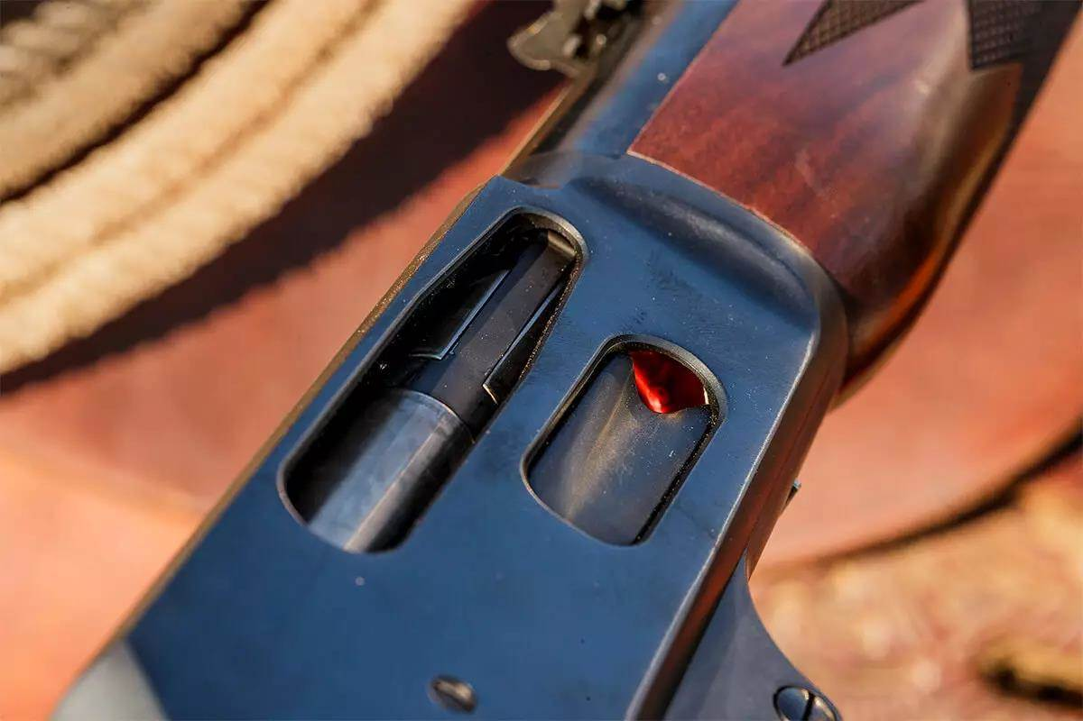
There is something to be said for the classic beauty of walnut and blued steel when you first hold the 336 Classic in your hands. Its “Classic” namesake rings true from barrel to buttstock. The 20.25-inch tapered barrel is cold-hammer-forged alloy steel, and features six rifling grooves in a 1:11-inch right-hand twist. This is a departure from many of the earlier Model 336s, which featured shallow micro-groove rifling. The micro groove was cheaper for Marlin to mass-produce but was always controversial for its departure from more traditional rifling. The modern cold-hammer-forging creates highly consistent rifling and a stronger, more heat-resistant barrel overall. For years, Ruger has had a handle on mass-producing cold-hammer-forged barrels and took this know-how into the Marlin line.
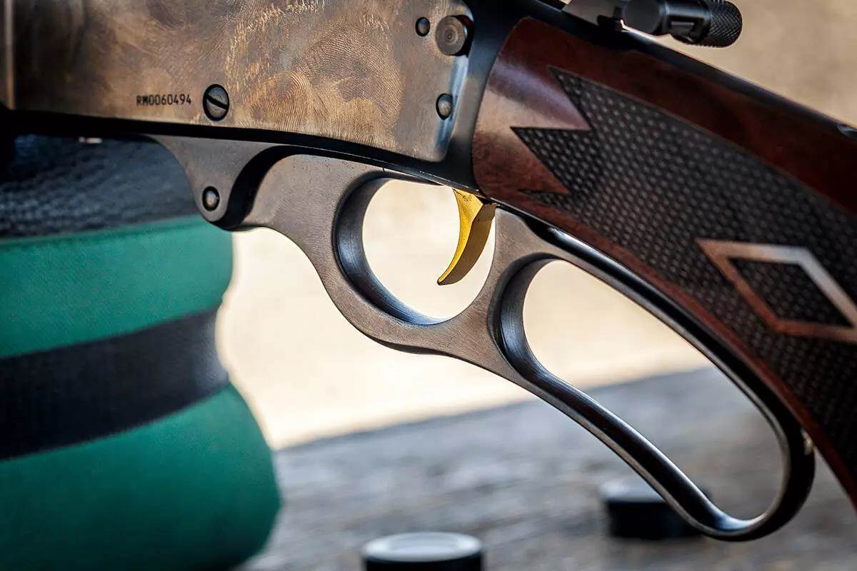
Mounted atop the barrel is an adjustable semi-buckhorn rear sight with a shrouded brass bead in the front. Underneath the barrel is a full-length tubular magazine, which can hold six rounds fed through the side loading gate in the receiver. A steel band secures the magazine to the barrel, and a second band secures the walnut forend in place. A forward sling-swivel is mounted to the forend barrel band, and the rear sling swivel is mounted to the buttstock. The matte-finished American black walnut stock and forend are eye-catching and feature clean-cut diamond checkering, which functions as good as it looks. The reddish-brown rubber buttpad does a nice job of softening the recoil and features the Marlin Horse and Rider logo molded into it. On the underside of the buttstock, just forward of the sling mount is the Marlin Bullseye inlay, a staple trademark feature of the brand’s rifles since 1922. The bullseye is now red and white, instead of the black and white it was on pre-Ruger models.
The base of the pistol grip is capped and features an inset medallion with the Marlin Horse and Rider. The receiver, lever and triggerguard plate are made from high-strength alloy steel forgings. Through improved CNC machining, Ruger was able to keep tolerances tight, while refining the internal components to function as reliably as possible. The polished bolt glides in and out of the receiver effortlessly, while its side-ejection port and drilled and tapped flat-top receiver make it ideal as an optic host. The lever itself is curved to match the pistol grip stock, and there is more than sufficient space for my last three fingers in the loop. Due to the precision machining, the lever has virtually no side-to-side movement, something that could be found in the earlier models.
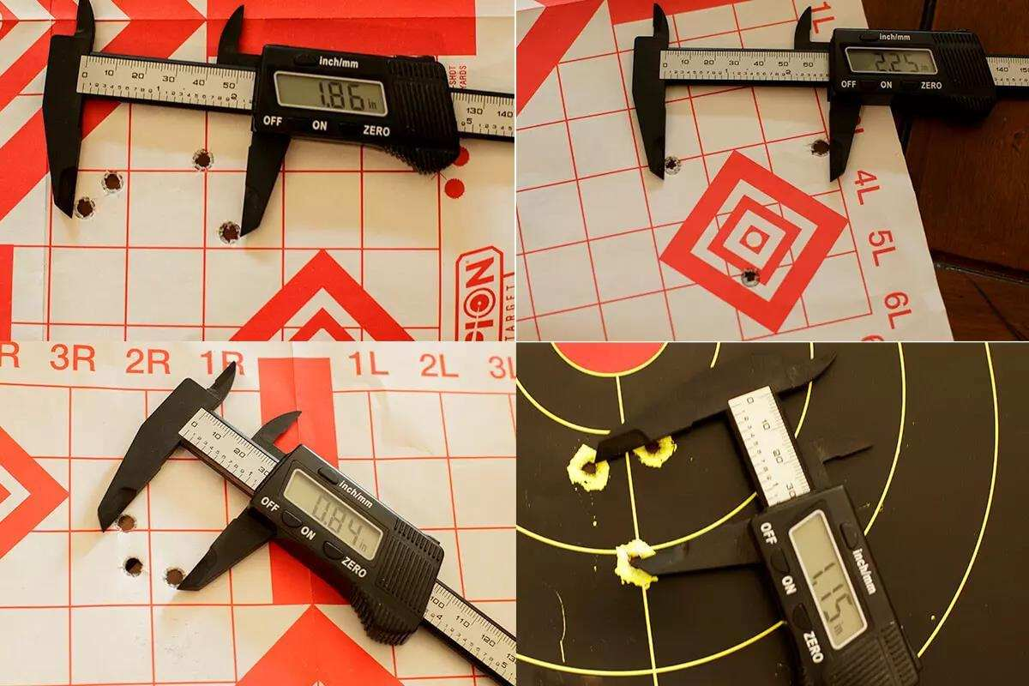
The trigger itself stands out, thanks to its gold color, a feature that has been a part of the 336 since the late 1950s. The pull weight was my only gripe, and a small one at that. My Wheeler trigger scale measured at 6.75 pounds straight out of the box and admittedly, it felt a bit “clunky.” This heavy trigger was truly surprising to me, as I’d heard these new Marlins had triggers around four to five pounds. However, my past experience working for a firearms manufacturer taught me that occasionally, things can get past quality-control checks. All tests with this rifle were completed using the factory trigger. After all my testing for this review, the weight has remained the same, but the “clunky” feel has gone away, making it feel much cleaner. I did contact Ruger/Marlin’s customer service, and as of the time of this publication, a replacement trigger has been shipped out on their dime. I certainly appreciate the company standing behind their product. Safety features on the rifle are plentiful. Like most lever guns, the hammer has a half-cocked position. On top of that is a redundant cross-bolt safety, which can only be engaged when the hammer is either in the half or fully cocked position. The trigger can still be pulled, and the hammer dropped when the safety is engaged, but it blocks the hammer from fully falling on the firing pin. The rifle also features a safety disconnect system which will not allow the rifle to be fired unless the lever and bolt are fully closed. Included in the box is an offset hammer spur, which can be installed to ensure safe cocking and de-cocking when there is a scope mounted on the rifle.
Mounting an Optic
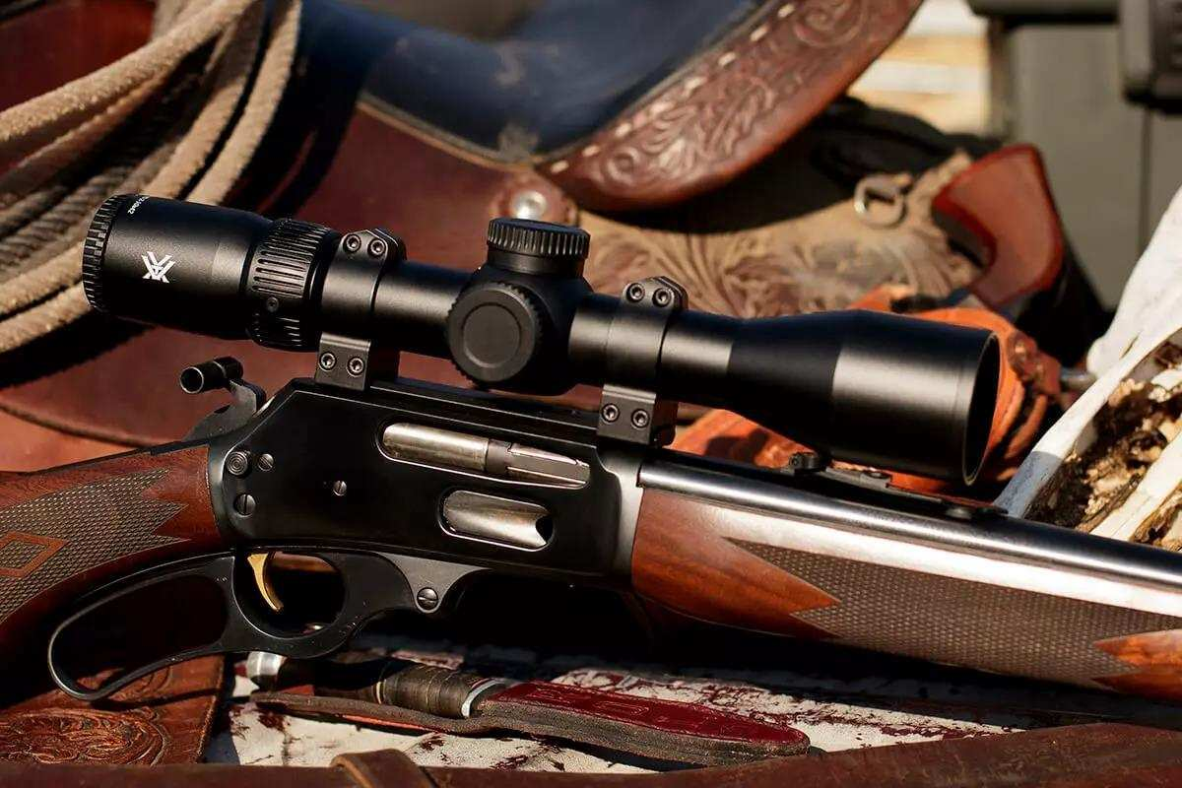
See Photo Gallery

I wanted the option to mount an optic to this rifle but also remove it if I didn’t feel it was necessary. I reached out to Warne Scope Mounts to see what they recommended I use. They suggested their one-piece Maxima scope base, and a set of their Maxima 30mm steel Quick Detach rings. The Maxima base sits low enough to allow me to use the iron sights over top of it, and Warne guarantees a return-to-zero with the QD rings. I did test the QD guarantee and was pleased to see it indeed held zero when removed and replaced back on the rifle. For the optic itself, I chose Vortex’s new Viper HD 2-10x42. Using HD glass and special coatings, Vortex created this optic to be ideal for hunting in low light situations. With a magnification range just wider than the classic 3-9x40, this compact optic sits pretty atop the Marlin. The 10X Magnification made accuracy testing at 100 yards a whole lot easier than trying to test accuracy with iron sights. The Deadhold BDC reticle allows the user to stretch the range out a bit with three additional subtensions. The center dot illumination features ten brightness settings to adjust based on your ambient lighting situation.

Photo Gallery




At the Range
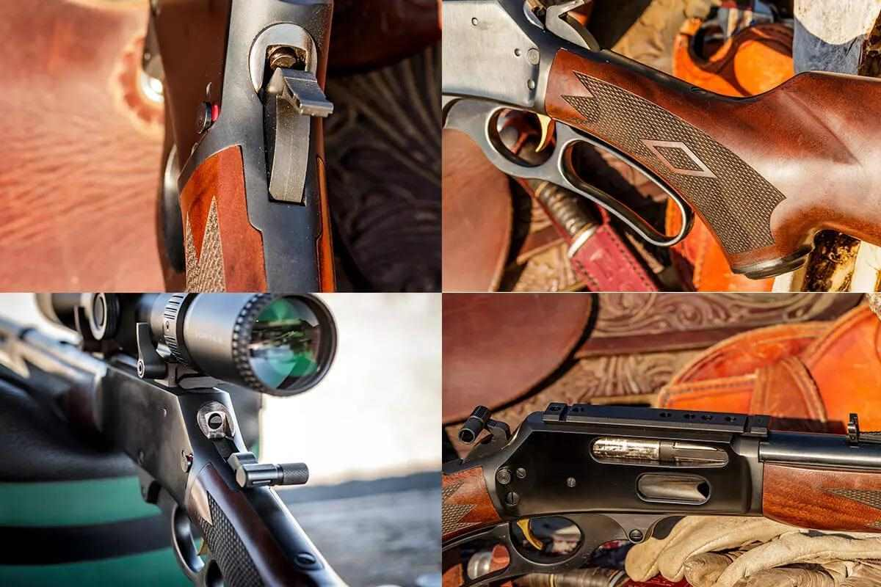

I tested four different ammunition types in the rifle, and every single one cycled flawlessly through the action. Offerings from Hornady, Federal and Remington were all tested. Depending on the ammo, groups ranged from 0.78 inches to 2.25 inches at 100 yards. All these group sizes would be acceptable in the 336’s ideal 200+/- yard range for hunting deer-sized game. Ruger knew when they acquired the Marlin brand, it was more than just a name. It was intended to be an heirloom that could be passed down from generation to generation. With the 336 Classic, they’ve done just that. The satin finished walnut and blued steel is a timeless look, while the modern manufacturing techniques and materials ensure it’s a rifle that will be handed down for years to come.
